User Guide for Weather station:

Program Description:

This program is a weather data desktop GUI that you can use to see various data in a series of XML files. The program then processes the data and display various graphs and calculation data.  
  
**Building and compiling:**  
 Run the weatherstation package through netbeans

Steps to run:

1. Open file in netbeans and run the code.
2. The GUI will pop up  
   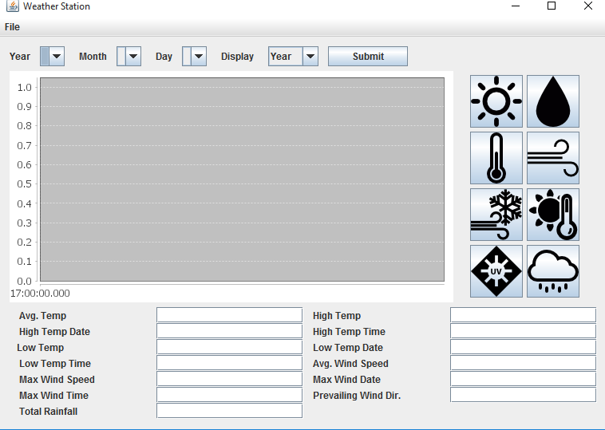
3. Click the file button then click open to bring up the file chooser:  
   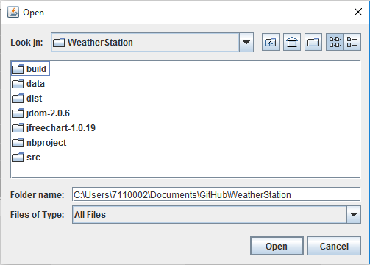
4. Select and open the directory containing the XML data files. Nothing will be in the directory since the file chooser is directory only:  
   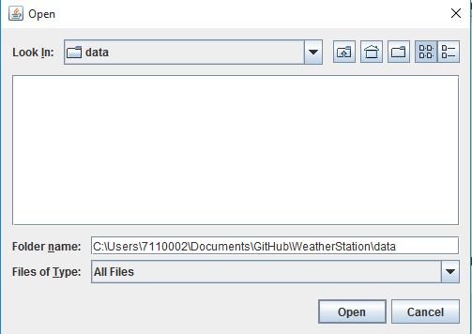
5. The directory will load in the XML files in the selected directory (this may take some time). Once complete the drop boxes will be populated and you can use the drop downs to select a year, month, or day. Then you select what type you want to display (year, week, month, day). Displaying week will go off of the selected day.  
   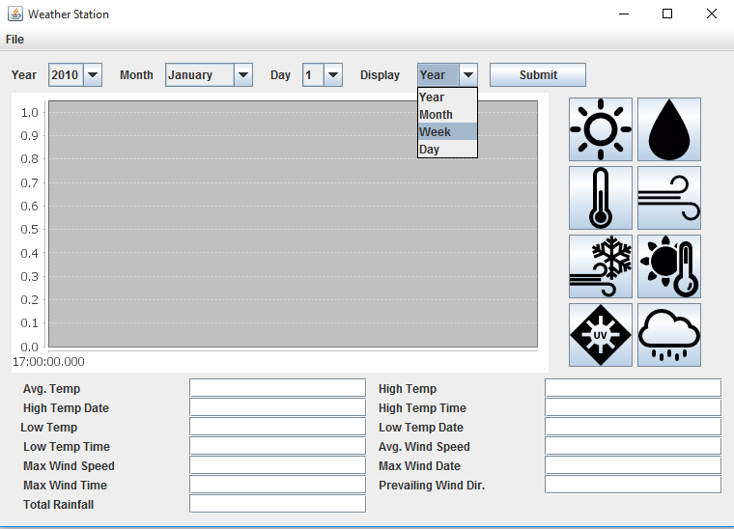
6. Once your drop boxes are selected hit the submit button, the data from the selected timeframe will be pulled. Then click the buttons on the left to turn the respective graphs on and off. The data at the bottom will also be filled base on selected time frame.  
   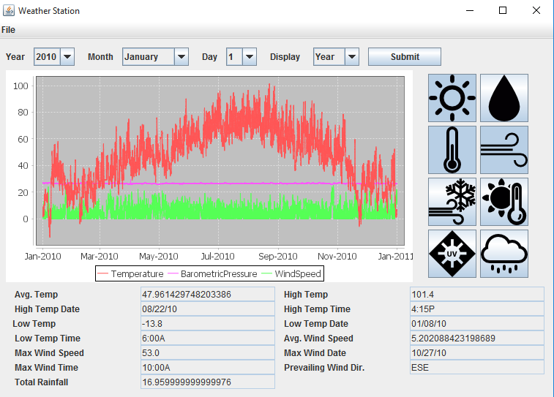
7. Once the graph is on the screen the user can hover over a point to get all the information for the point.  
   